**Problem – 1.**

**Create an HBase table named 'clicks' with a column family 'hits' such that it should be able to**

**store last 5 values of qualifiers inside 'hits' column family.**

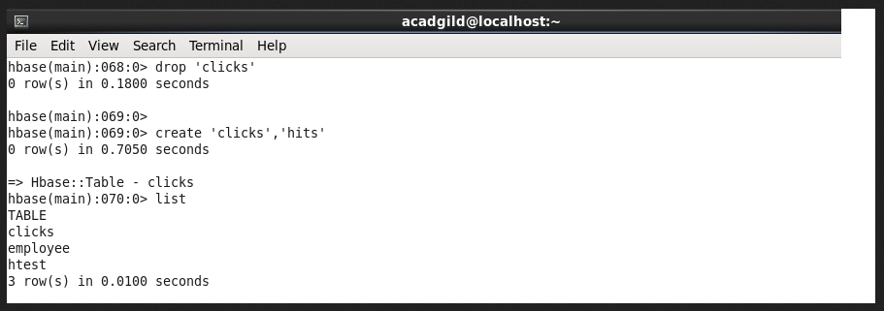

**Inserting 5 - values into clicks table:**

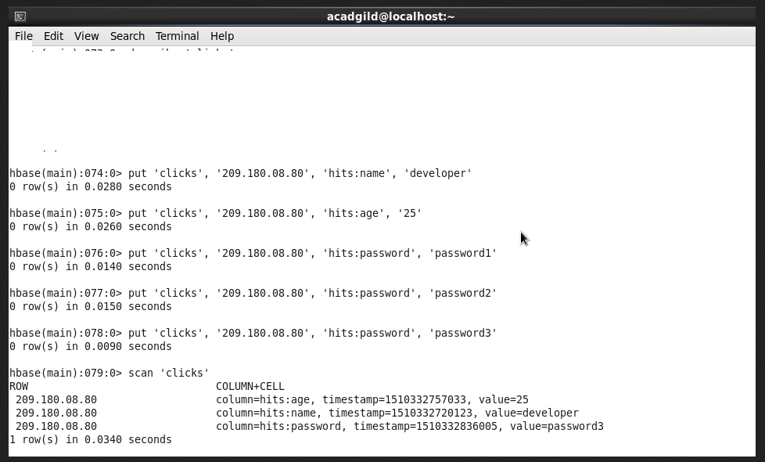

**Problem – 2**

**Add few records in the table and update some of them. Use IP Address as row-key. Scan the**

**table to view if all the previous versions are getting displayed.**

